AmeriCorps Performance Measures Instructions

AmeriCorps State and National

2023

Table of Contents
AmeriCorps State and National Performance Measure Requirements 3
AmeriCorps State and National Performance Measures Selection Rules 4
CAPACITY BUILDING 10
DISASTER SERVICES 11
ECONOMIC OPPORTUNITY 12
EDUCATION 14
ENVIRONMENTAL STEWARDSHIP 17
HEALTHY FUTURES 20
VETERANS AND MILITARY FAMILIES 22
Appendix A: Understanding MSY and Member Allocations 23
Appendix B: Performance Measures Checklist 27
Appendix C: Frequently Asked Questions 29

AmeriCorps State and National Performance Measure Requirements
All applications must include at least one aligned performance measure (output paired with outcome) that corresponds to the proposed primary intervention. This may be a National Performance Measure or an applicant-determined measure depending on the program’s theory of change. Applications may also include National Performance Measure outputs without associated outcome(s) provided that the output measures a significant program activity. These output-only measures do not fulfill the requirement for an aligned performance measure, but may be selected in addition to the aligned measure(s).
All performance measures must reflect significant program activities whose outputs and outcomes are consistent with the applicant’s core theory of change. Applicants are not expected to have performance measures for every program activity. AmeriCorps does not require applicants to use National Performance Measures but expects them to do so if National Performance Measures reflect key outputs and/or outcomes of the theory of change. Applicants may not create applicant determined outputs or outcomes that duplicate existing National Performance Measures.

All performance measures, including output-only measures, must be associated with one or more interventions (service activities). Applicants are expected to use the system-defined intervention categories if they appropriately represent the applicant’s program activities. Applicants may not create user-defined intervention labels that duplicate existing intervention categories.

AmeriCorps State and National Performance Measures Selection Rules
These selection rules specify allowable output/outcome pairings for National Performance Measures. Applicants must follow these selection rules when using National Performance Measures. Applicants may not select any National Performance Measures that may appear in eGrants if they are not present on this list. Please see the NOFO for additional information about application requirements.

Capacity Building

Strategic Plan Objective | Selection Rules |  | Interventions
 | Outputs | Outcomes (if applicable)*
Capacity Building & Leverage | G3-3.4: Number of organizations that received capacity building services | G3-3.10A: Number of organizations that increase their efficiency, effectiveness, and/or program reach | Volunteer management  Training  Resource development  Systems development
*All National Performance Measure outputs may also be paired with an applicant-determined outcome instead or may be used without an associated outcome.

Disaster Services

Strategic Plan Objective | Selection Rules |  | Interventions
 | Outputs | Outcomes (if applicable)*
Assistance Provided | D1A: Number of individuals served | D5: Number of individuals reporting increased disaster readiness | Disaster Preparation  Disaster Response  Disaster Recovery  Disaster Mitigation  Disaster Adaptation  Climate Change Intervention
 | D6: Number of structures protected or restored | D7: Number of structures returned to regular use after a disaster | Disaster Preparation  Disaster Response  Disaster Recovery  Disaster Mitigation  Disaster Adaptation  Climate Change Intervention
 | EN4**: Acres of parks or public land treated | EN4.1**: Acres of parks or public land improved | Disaster Preparation  Disaster Response  Disaster Recovery  Disaster Mitigation  Disaster Adaptation  Climate Change Intervention
 | EN5**: Miles of trails or rivers treated. | EN5.1**: Miles of trails or rivers improved | Disaster Preparation  Disaster Response  Disaster Recovery  Disaster Mitigation  Disaster Adaptation  Climate Change Intervention
 | G3-3.4**: Number of organizations that received capacity building services | G3-3.10A**: Number of organizations that increase their efficiency, effectiveness, and/or program reach | Disaster Preparation  Disaster Response  Disaster Recovery  Disaster Mitigation  Disaster Adaptation  Climate Change Intervention
*All National Performance Measure outputs may also be paired with an applicant-determined outcome instead or may be used without an associated outcome.

**In the eGrants Performance Measure Module, these measures may appear with the letter “D” at the end when used in the Disaster Services focus area. However, the instructions for these measures are the same regardless of the focus area in which they are used.
Economic Opportunity

Strategic Plan Objective | Selection Rules |  | Interventions
 | Outputs | Outcomes (if applicable)*
Financial Literacy | O1A: Number of individuals served | O9: Number of individuals with improved financial knowledge | Financial Literacy Education
Housing | O1A: Number of individuals served | O11: Number of individuals transitioned into safe, healthy, affordable housing | Housing Unit Development  Housing Unit Repair  Housing Placement/Assistance
 | O4: Number of housing units developed or repaired | O20: Number of safe, healthy, affordable housing units made available | Housing Unit Development  Housing Unit Repair
Employment | O1A: Number of individuals served | O10: Number of individuals who secure employment  O21: Number of individuals with improved job readiness | Job Training  Job Placement  GED Education  Other Adult Education
Find Opportunity | N/A (outputs may be reported as Performance Data Elements on annual Progress Reports) | N/A (outcomes may be reported as Performance Data Elements on annual Progress Reports) | N/A
Other Economic Opportunity | O1A: Number of individuals served | Applicant-determined | Applicant-determined
*All National Performance Measure outputs may also be paired with an applicant-determined outcome instead or may be used without an associated outcome.
Education

Strategic Plan Objective | Selection Rules |  | Interventions
 | Outputs | Outcomes (if applicable)*
School Readiness | ED1A: Number of individuals served | ED23A: Number of children demonstrating gains in school readiness | Tutoring  Mentoring  Other Classroom Support  Out-of-School Time  Family Involvement  Service Learning  Summer Learning  Classroom Teaching
K-12 Success | ED1A: Number of individuals served | ED5A: Number of students with improved academic performance  ED9: Number of students graduating from high school on time  ED10: Number of students enrolling in post-secondary education/training  ED27C: Number of students with improved academic engagement or social-emotional skills  ED6: Number of students with increased attendance  ED7A: Number of students with decreased disciplinary incidents (referrals, suspensions/expulsions, criminal or gang involvement) | Tutoring  Mentoring  Coaching  Other Classroom Support  Out-of-School Time  Family Involvement  Service Learning  Summer Learning  Classroom Teaching  Opioid/Drug Intervention
Post-HS Education Support | ED1A: Number of individuals served | ED11: Number of individuals earning a post-secondary degree or technical certification | Tutoring  Mentoring  Family Involvement  Service Learning  Summer Learning
Teacher Corps | N/A (outputs may be reported as Performance Data Elements on annual Progress Reports) | N/A (outcomes may be reported as Performance Data Elements on annual Progress Reports) | N/A
Other Education | ED1A: Number of individuals served | Applicant-determined | Applicant-determined
*All National Performance Measure outputs may also be paired with an applicant-determined outcome instead or may be used without an associated outcome.

Environmental Stewardship

Strategic Plan Objective | Selection Rules |  | Interventions
 | Outputs | Outcomes (if applicable)*
At-Risk Ecosystems | EN4: Acres of parks or public land treated | EN4.1: Acres of parks or public land improved | Fire Mitigation  Flood Mitigation  Invasive Species Removal  Debris Removal  Plant Establishment  Climate Change Intervention
 | EN5: Miles of trails or rivers treated. | EN5.1: Miles of trails or rivers improved | Trail Creation  Trail Remediation  Stream Remediation  Fire Mitigation  Flood Mitigation  Invasive Species Removal  Debris Removal  Plant Establishment  Climate Change Intervention
Energy Efficiency | EN1: Number of housing units or public structures weatherized or retrofitted to improve energy efficiency | EN1.1: Number of housing units or public structures with reduced energy consumption or reduced energy costs | Weatherization  Retrofitting  Climate Change Intervention
Awareness & Stewardship | EN3: Number of individuals receiving education or training in environmental stewardship and/or environmentally-conscious practices | EN3.1: Number of individuals with increased knowledge of environmental stewardship and/or environmentally-conscious practices  EN3.2: Number of individuals reporting a change in behavior or intention to change behavior to better protect the environment | Education/Training  Service Learning  Climate Change Intervention
Green Jobs | N/A (outputs may be reported as Performance Data Elements on annual Progress Reports) | N/A (outcomes may be reported as Performance Data Elements on annual Progress Reports) | N/A
*All National Performance Measure outputs may also be paired with an applicant-determined outcome instead or may be used without an associated outcome.

Healthy Futures

Strategic Plan Objective | Selection Rules |  | Interventions
 | Outputs | Outcomes (if applicable)*
Aging in Place | H4A: Number of individuals served | H9A: Number of individuals who report improved capacity for independent living  H19: Number of individuals with improved health | Companionship  Nutrition/Food Support  Legal Services  Transportation  Medical Services  Opioid/Drug Intervention
Obesity & Food | H4A: Number of individuals served | H12: Number of individuals who report increased food security  H17: Number of individuals with increased health knowledge  H18: Number of individuals reporting a change in behavior or intent to change behavior to improve their health  H19: Number of individuals with improved health | Outreach  Education/Training  Referrals  Medical Services  Nutrition/Food Support  Physical Activities  Counseling/Coaching  Opioid/Drug Intervention
 | H10A: Number of pounds of food provided | Applicant-determined | Nutrition/Food Support
Access to Care | H4A: Number of individuals served | H17: Number of individuals with increased health knowledge  H18: Number of individuals reporting a change in behavior or intent to change behavior to improve their health  H19: Number of individuals with improved health  H20: Number of individuals with improved access to medical care | Outreach  Education/Training  Referrals  Medical Services  Counseling/Coaching  Opioid/Drug Intervention
Other Healthy Futures | H4A: Number of individuals served | Applicant-determined | Applicant-determined
*All National Performance Measure outputs may also be paired with an applicant-determined outcome instead or may be used without an associated outcome.
Veterans and Military Families

Strategic Plan Objective | Selection Rules |  | Interventions
 | Outputs | Outcomes (if applicable)*
Veterans & Families Served | V1: Number of veterans served  V7A: Number of active military members and/or military family members served  V8: Number of veteran family members served | O9**: Number of individuals with improved financial knowledge  O11**: Number of individuals transitioned into safe/affordable housing  O10**: Number of individuals who secure employment  O21**: Number of individuals with improved job readiness  ED11**: Number of individuals earning a post-secondary degree or technical certification  H9A**: Number of individuals who report improved capacity for independent living  H12**: Number of individuals who report increased food security  H17**: Number of individuals with increased health knowledge  H18**: Number of individuals reporting a change in behavior or intent to change behavior to improve their health  H19**: Number of individuals with improved health  H20**: Number of individuals with improved access to medical care | Financial Literacy Education  Housing Unit Development  Housing Unit Repair  Housing Placement/Assistance  Job Training  Job Placement  GED Education  Other Adult Education  Tutoring  Mentoring  Family Involvement  Service Learning  Summer Learning  Companionship  Nutrition/Food Support  Legal Services  Transportation  Outreach  Referrals  Medical Services  Physical Activities  Counseling/Coaching  Opioid/Drug Intervention
Access & Attract | N/A (outputs may be reported as Performance Data Elements on annual Progress Reports) | N/A (outcomes may be reported as Performance Data Elements on annual Progress Reports) | N/A
*All National Performance Measure outputs may also be paired with an applicant-determined outcome instead or may be used without an associated outcome.

**In the eGrants Performance Measure Module, these measures may appear with the letter “V” at the end when used in the Veterans and Military Families focus area. However, the instructions for these measures are the same regardless of the focus area in which they are used.

CAPACITY BUILDING
Focus Area Notes
- Programs should only opt into the Capacity Building performance measures if the measures reflect significant program activities aligned with the applicant’s core theory of change.
- Activities associated with these measures must be carried out by National Service Participants or by volunteers directly recruited and/or supported by National Service Participants.
- Activities associated with these measures must meet the definition of capacity building specified in the “key terms” definition under G3-3.4.
- Programs are not permitted to create applicant-determined outputs in the Capacity Building focus area.

G3-3.4 (output) | Number of organizations that received capacity building services
Definition of Key Terms | Organization: nonprofit or state/local/tribal government entity  Capacity building services: a set of activities that expand the scale, reach, efficiency, or effectiveness of programs and organizations. Capacity building activities may also leverage resources (e.g., funding, volunteers, in-kind support, or partnerships) for programs and/or organizations. As a general rule, AmeriCorps considers capacity building activities to be indirect services that enable organizations to provide more, better and sustained direct services. Capacity building activities must (1) be intended to support or enhance the program delivery model, (2) respond to the organization’s goal of increasing, expanding or enhancing services in order to address pressing community needs, and (3) enable the organization to provide a sustained level of more or better direct services after the national service participant’s term of service has ended.
How to Measure/  Collect Data | Tracking mechanism that ensures an unduplicated count of organizations who have received services

G3-3.10A (outcome) | Number of organizations that increased their effectiveness, efficiency, and/or program scale/reach
Definition of  Key Terms | Organizations: those counted in G3-3.4  Effectiveness: Improved ability of the organization to achieve outcomes resulting in better success rates or better quality of outcomes achieved  Efficiency: Improved outcomes with the same level of resources; improved or consistent quality of services with fewer resources  Scale/Reach: The scope of a program’s services. Increased scale/reach can be measured by the number of new people served, new populations served, and/ or new or expanded services.
How to Measure/  Collect Data | Organizational assessment tool or other instrument capable of measuring changes in effectiveness, efficiency, or scale/reach at the organization level. When possible, pre-post assessments should be utilized.

DISASTER SERVICES

Focus Area Notes
- Programs should only opt into the Disaster Services performance measures if the measures reflect significant program activities aligned with the applicant’s core theory of change.
- Any other grantees who provide disaster-related services during the program year should report on this activity in the Performance Data Elements in annual Progress Reports and provide a brief description of those services.
- To ensure unduplicated counts, beneficiaries reported under National Performance Measures in the Disaster Services focus area should not also be reported in disaster-related Performance Data Elements in annual Progress Reports.
- Activities associated with these measures must be carried out by National Service Participants or by volunteers directly recruited and/or supported by National Service Participants.
- All individuals counted under these measures must be program beneficiaries, not National Service Participants. National Service Participant outputs and outcomes should be reported in the Performance Data Elements in annual Progress Reports.
D1A (output) | Number of individuals served
Definition of Key Terms | Individuals: recipients of AmeriCorps-supported services related to disaster preparedness, response, recovery, and/or mitigation  Served: substantive engagement of individuals with a specific disaster-related goal in mind. Cannot consist solely of mass dissemination of information such as email blasts, social media posts, or distributing pamphlets.
How to Measure/  Collect Data | Tracking mechanism that ensures an unduplicated count of individuals who have received services

D5 (outcome) | Number of individuals reporting increased disaster readiness
Definition of Key Terms | Individuals: those reported in measure D1A  Disaster readiness: measures taken to prepare for and reduce the effects of future disasters
How to Measure/  Collect Data | Survey, interview, or other instrument capable of measuring changes in disaster readiness at the individual beneficiary level. When possible, pre-post assessments should be utilized.

D6 (output) | Number of structures protected or restored
Definition of Key Terms | Structures: housing units or public facilities  Protected: prepared to more effectively withstand future disasters  Restored: repaired from damage sustained during a disaster
How to Measure/  Collect Data | Tracking mechanism that ensures an unduplicated count of structures that received services

D7 (outcome) | Number of structures returned to regular use after a disaster
Definition of Key Terms | Structures: those reported in measure D6  Returned to regular use: able to be used for the same or similar purpose for which they were used prior to the disaster
How to Measure/  Collect Data | Report from structure owner/manager/occupant, or other instrument capable of measuring changes in condition at the individual structure level.

ECONOMIC OPPORTUNITY
Focus Area Notes
- Programs should only opt into the Economic Opportunity performance measures if the measures reflect significant program activities aligned with the applicant’s core theory of change.
- All individuals counted under these measures must be program beneficiaries, not National Service Participants. National Service Participant outputs and outcomes should be reported in the Performance Data Elements in annual Progress Reports.
- Activities associated with these measures must be carried out by National Service Participants or by volunteers directly recruited and/or supported by National Service Participants.

O1A (output) | Number of individuals served
Definition of Key Terms | Individuals: recipients of AmeriCorps-supported services related to increasing economic opportunity  Served: substantive engagement of individuals with a specific goal in mind related to economic opportunity. Cannot consist solely of mass dissemination of information such as email blasts, social media posts, or distributing pamphlets.
How to Measure/  Collect Data | Tracking mechanism that ensures an unduplicated count of individuals who have received services

O4 (output) | Number of housing units developed or repaired
Definition of Key Terms | Housing unit: A single-family home (including a mobile home if permanently placed), an apartment, or a room in a group home for people with disabilities  Develop: Build new or substantially rehabilitate housing units that were uninhabitable or soon would have become so. Involves replacing major systems such as the roof, the plumbing, the wiring, the foundation, or elevating the unit as required by a flood plain standard.  Repair: A more modest level of physical work on the unit, such as weatherizing, painting, replacing appliances and removing safety hazards
How to Measure/  Collect Data | Tracking mechanism that ensures an unduplicated count of the number of housing units that have received AmeriCorps-supported development or repair services

O9 (outcome) | Number of individuals with improved financial knowledge
Definition of Key Terms | Individuals: those reported in measure O1A, V1, V7A, or V8  Improved financial knowledge: increased knowledge/understanding of financial literacy topics such as credit management, financial institutions including banks and credit unions, and utilization of savings plans
How to Measure/  Collect Data | Survey, interview, or other instrument capable of measuring changes in financial knowledge at the individual beneficiary level. When possible, pre-post assessments should be utilized.

O10 (outcome) | Number of individuals who secure employment
Definition of Key Terms | Individuals: those reported in measure O1A, V1, V7A, or V8  Secure employment: individual is hired in a new job as a result of AmeriCorps-supported services provided; individual may have been previously working in a different job or previously unemployed
How to Measure/  Collect Data | Preferred method is a copy of acceptance letter from employer or copy of first pay stub. Beneficiary self-reports may also be utilized.

O11 (outcome) | Number of individuals transitioned into safe, healthy, affordable housing
Definition of Key Terms | Individuals: those reported in measure O1A, V1, V7A, or V8  Safe, healthy, affordable housing: Grantee certifies that the housing is safe and healthy based on an inspection or other documentation. Grantee defines affordability and certifies that the housing is affordable to the individual(s) transitioned into the unit.
How to Measure/  Collect Data | Preferred method is a proof of residence such as a lease, mortgage, certificate of occupancy, or other verification from an external agency. Beneficiary self-reports may also be utilized.

O20 (outcome) | Number of safe, healthy, affordable housing units made available
Definition of Key Terms | Housing unit: those reported in measure O4  Safe, healthy, affordable housing unit: Grantee certifies that the housing unit is safe and healthy based on an inspection or other documentation. Grantee defines affordability and certifies that the housing unit is affordable.  Made available: This count indicates that the work has been completed to make the units available but they may or may not have been occupied.
How to Measure/  Collect Data | Tracking mechanism that ensures an unduplicated count of the number of safe, healthy, affordable housing units that have been made available

O21 (outcome) | Number of individuals with improved job readiness
Definition of Key Terms | Individuals: those reported in measure O1A, V1, V7A, or V8  Improved job readiness: increased knowledge or skills related to seeking, obtaining, or successfully retaining a job.
How to Measure/  Collect Data | Survey, interview, observation, or other instrument capable of measuring changes in job readiness at the individual beneficiary level. When possible, pre-post assessments should be utilized.

EDUCATION
Focus Area Notes
- Programs should only opt into the Education performance measures if the measures reflect significant program activities aligned with the applicant’s core theory of change.
- All individuals counted under these measures must be program beneficiaries, not National Service Participants. National Service Participant outputs and outcomes should be reported in the Performance Data Elements in annual Progress Reports.
- Activities associated with these measures must be carried out by National Service Participants or by volunteers directly recruited and/or supported by National Service Participants.
ED1A (output) | Number of individuals served
Definition of Key Terms | Individuals: recipients of AmeriCorps-supported services related to education; may include students enrolled in grades K-12, out-of-school youth, preschool age children, and/or individuals pursuing postsecondary education  Served: substantive engagement of individuals with a specific education-related goal in mind. Cannot consist solely of mass dissemination of information such as email blasts, social media posts, or distributing pamphlets.
How to Measure/  Collect Data | Tracking mechanism that ensures an unduplicated count of individuals who have received services

ED5A (outcome) | Number of students with improved academic performance
Definition of Key Terms | Students: those reported in ED1A  Improved academic performance: an improved demonstration of skill or knowledge in one or more academic subjects
How to Measure/  Collect Data | Standardized test, report card grade, or other instrument capable of measuring changes in academic performance at the individual beneficiary level. When possible, pre-post assessments should be utilized.

ED6 (outcome) | Number of students with increased school attendance
Definition of Key Terms | Students: those reported in ED1A  Increased school attendance: higher rate of presence and/or on-time arrival at school as compared to a previous comparable time period
How to Measure/  Collect Data | School/district/classroom attendance records or other instrument capable of measuring changes in attendance at the individual beneficiary level

ED7A (outcome) | Number of students with decreased disciplinary incidents (referrals, suspensions/expulsions, criminal or gang involvement)
Definition of Key Terms | Students: those reported in ED1A  Decreased disciplinary incidents: lower rate of incidents as compared to a previous comparable time period
How to Measure/  Collect Data | School/district/classroom records, police records, or other instrument capable of measuring changes in disciplinary incidents at the individual beneficiary level

ED9 (outcome) | Number of students graduating from high school on time with a diploma
Definition of Key Terms | Students: those reported in ED1A  On Time: Within four years of starting 9th grade
How to Measure/  Collect Data | Preferred method is school/district graduation records for student beneficiaries. Beneficiary self-reports may also be utilized.

ED10 (outcome) | Number of students enrolling in post-secondary education or training
Definition of Key Terms | Students: those reported in ED1A  Post-secondary education or training may include two- or four-year college programs or occupational/vocational programs  Enrolling: means matriculating as a full-time or part-time student
How to Measure/  Collect Data | Preferred method is registration records that confirm student enrollments. Beneficiary self-reports may also be utilized.

ED11 (outcome) | Number of students earning a post-secondary degree
Definition of Key Terms | Students: those reported in ED1A, V1, V7A, or V8  Degree: may include an associate degree from an accredited academic program or an occupational or vocational program; a bachelor’s degree (ex., BA, BS); a master’s degree (ex.: MA, MS, MEng, MEd, MSW); a professional school degree (ex.: MD, DDS, DVM); or a doctorate degree (ex.: PhD, EdD)
How to Measure/  Collect Data | Preferred method is registration records that confirm degree was earned. Beneficiary self-reports may also be utilized.
Notes | Programs may only select this measure if they are able to collect data during a one-year grant period.

ED23A (outcome) | Number of children demonstrating gains in school readiness
Definition of Key Terms | Children: those reported in ED1A  School readiness: Preparation for Kindergarten which includes multiple indicators assessed across developmental and behavioral domains including but not limited to physical well-being, health and motor development, social and emotional development, approaches to learning, language development, cognitive development, and age-appropriate academic skills and behavior.
How to  Measure/  Collect Data | Teacher observation, standardized test, or other instrument capable of measuring changes in school readiness at the individual beneficiary level. When possible, pre-post assessments should be utilized.

ED27C (outcome) | Number of students with improved academic engagement or social and emotional skills
Definition of  Key Terms | Students: those reported in ED1A  Improved academic engagement or social and emotional skills: A positive change in student skills, attitude, and/or mindset that is likely to contribute to increased educational success. May include increased interest in school, improved perspective on school climate, increased attachment to school and/or increased educational aspirations.
How to Measure/  Collect Data | Survey, observation, or other instrument capable of measuring changes in academic engagement or social and emotional skills at the individual beneficiary level. When possible, pre-post assessments should be utilized.
Notes | Academic or behavioral improvements counted under ED5A, ED6, or ED7A cannot be counted under this measure

ENVIRONMENTAL STEWARDSHIP

Focus Area Notes
- Programs should only opt into the Environmental Stewardship performance measures if the measures reflect significant program activities aligned with the applicant’s core theory of change.
- All individuals counted under these measures must be program beneficiaries, not National Service Participants. National Service Participant outputs and outcomes should be reported in the Performance Data Elements in annual Progress Reports.
- Activities associated with these measures must be carried out by National Service Participants or by volunteers directly recruited and/or supported by National Service Participants.
- AmeriCorps encourages grantees to perform service with the greatest impact versus providing minimal impact to the highest number of acres/miles/individuals
EN1 (output) | Number of housing units or public structures weatherized or retrofitted to improve energy efficiency
Definition of  Key Terms | Housing unit: a single-family home (including a mobile home if permanently placed), an apartment, or a room in a group home for people with disabilities  Public structure: Shelter, such as homeless shelter or emergency shelter operated by a nonprofit or government organization; government-owned building  Weatherization: Modifying a building to reduce energy consumption and costs and optimize energy efficiency. Whole-house weatherization includes the installation of modern energy-saving heating and cooling equipment and looks at how the house performs as a system.  Retrofit: An energy conservation measure applied to an existing building or the action of improving the thermal performance or maintenance of a building.
How to Measure/  Collect Data | Tracking mechanism that ensures an unduplicated count of units/structures that have received services

EN1.1 (outcome) | Number of housing units or public structures with reduced energy consumption or reduced energy costs
Definition of Key Terms | Housing units or public structures: those reported in EN1
How to Measure/  Collect Data | Utility bill/statement, computer modeling, resident survey, or other instrument capable of measuring changes in energy consumption or energy costs at the individual unit/structure level. When possible, pre-post assessments should be utilized.

EN3 (output) | Number of individuals receiving education or training in environmental stewardship and/or environmentally-conscious practices
Definition of  Key Terms | Environmental Stewardship and/or environmentally conscious practices: Organized efforts to teach about how natural environments function and, particularly, how human beings can manage their behavior and choices in order to live sustainably within those environments.  Education or training: substantive engagement of individuals with a specific education goal in mind. Cannot consist solely of mass dissemination of information such as email blasts, social media posts, or distributing pamphlets.
How to Measure/  Collect Data | Tracking mechanism that ensures an unduplicated count of individuals that have received services

EN3.1 (outcome) | Number of individuals with increased knowledge of environmental stewardship and/or environmentally-conscious practices
Definition of  Key Terms | Individuals: those reported in EN3
How to Measure/  Collect Data | Survey, test, or other instrument capable of measuring changes in knowledge at the individual beneficiary level. When possible, pre-post assessments should be utilized.

EN3.2 (outcome) | Number of individuals reporting a change in behavior or the intent to change behavior to better protect the environment
Definition of  Key Terms | Individuals: those reported in EN3
How to Measure/  Collect Data | Survey, interview, or other instrument capable of measuring changes in behavior at the individual beneficiary level. When possible, pre-post assessments should be utilized.

EN4 (output) | Number of acres of public parks or other public and tribal lands that are treated
Definition of  Key Terms | Public parks: Park/recreation areas that are designated by national, state, city, or county governments (not trails or rivers; see EN5)  Other public lands: Other publicly owned lands; land owned by nonprofits for public use or the public good (such as land conservancies): and public easements  Tribal lands: Same meaning as imparted by the definitions of “Indian Lands” and “Indian Tribes” provided in. SEC. 101. [42 U.S.C. 12511]  Treated: Removal of invasive species, planting native plants, building riparian buffers, clearing of natural debris (such as fallen trees/limbs, hazardous fuel) and unnatural debris (such as disaster debris and improperly disposed waste). Treatment must go beyond basic trash removal.
How to Measure/  Collect Data | Tracking mechanism that ensures an unduplicated count of acres of land that have received services

EN4.1 (outcome) | Number of acres of public parks or other public and tribal lands that are improved
Definition of  Key Terms | Acres of public parks or other public and tribal lands: those reported in EN4  Improved: Renovated to reduce human impact or the negative impact of natural disasters or invasive species, restored native plants and habitat, reduced erosion, protected watersheds, reduced wildfire risk, upgraded or repaired outdoor recreation facilities or signage, increased public safe access, protected flora and fauna. Improvement should be consistent with an accepted natural resource restoration, maintenance or improvement plan.
How to Measure/  Collect Data | Land manager assessment or other instrument capable of measuring changes in land condition at the scale of individual acres. When possible, pre-post assessments should be utilized.

EN5 (output) | Number of miles of public trails or waterways that are treated and/or constructed
Definition of  Key Terms | Public trails or waterways: owned/maintained by national, state, county, city or tribal governments; nonprofits when for public use or the public good; and public easements  Treated: Removal of invasive species, planting native plants, building riparian buffers, improving tread/corridor of existing trail or making changes to increase the trail lifespan, implementing safety measures, removal of unsafe trail structures, repair of damage caused by visitor use, changes to increase accessibility, clearing of natural debris (such as fallen trees/limbs and hazardous fuel) and unnatural debris (such as disaster debris and improperly disposed waste). Treatments must go beyond basic trash removal.  Constructed: Activities designed to make trails newly available such as adding handicapped accessibility, building boardwalks, trail-blazing, converting a railroad bed to a trail, etc.
How to Measure/  Collect Data | Tracking mechanism that ensures an unduplicated count of miles of trail/waterway that have received services

EN5.1 (outcome) | Number of miles of public trails or waterways that are improved and/or put into use
Definition of  Key Terms | Miles of public trails or waterways: those reported in EN5  Improved: Restored to reduce human impact or the negative impact of natural disasters or invasive species, restored native plants and habitat, reduced erosion, protected watersheds, increased safe condition or long-term sustainability of trails, increased accessibility, protected flora and fauna. Improvement should be consistent with an accepted natural resource restoration, maintenance or improvement plan.  Put into use: Established safe and useable trails that are now available for public access
How to Measure/  Collect Data | Land manager assessment or other instrument capable of measuring changes in trail or waterway condition at the scale of individual miles. When possible, pre-post assessments should be utilized.

HEALTHY FUTURES

Focus Area Notes
- Programs should only opt into the Healthy Futures performance measures if the measures reflect significant program activities aligned with the applicant’s core theory of change.
- All individuals counted under these measures must be program beneficiaries, not National Service Participants. National Service Participant outputs and outcomes should be reported in the Performance Data Elements in annual Progress Reports.
- Activities associated with these measures must be carried out by National Service Participants or by volunteers directly recruited and/or supported by National Service Participants.

H4A (output) | Number of individuals served
Definition of  Key Terms | Individuals: recipients of AmeriCorps-supported services related to improving health-related outcomes  Served: substantive engagement of individuals with a specific health-related goal in mind. Cannot consist solely of mass dissemination of information such as email blasts, social media posts, or distributing pamphlets.
How to Measure/  Collect Data | Tracking mechanism that ensures an unduplicated count of individuals who have received services

H9A (outcome) | Number of individuals who report improved capacity for independent living
Definition of  Key Terms | Individuals: those reported in H4A, V1, V7A, or V8
How to Measure/  Collect Data | Survey, interview, caseworker assessment, or other instrument capable of measuring changes in independent living capacity at the individual beneficiary level. When possible, pre-post assessments should be utilized.

H10A (output) | Number of pounds of food provided
Definition of  Key Terms | Food provided: made available at reduced or no cost to individuals and/or organizations for the purpose of alleviating food insecurity or hunger. May include community garden programs.
How to Measure/  Collect Data | Tracking mechanism that ensures an unduplicated count of pounds of food provided

H12 (outcome) | Number of individuals who report increased food security
Definition of  Key Terms | Individuals: those reported in H4A, V1, V7A, or V8  Food security: Access at all times to enough food for an active, healthy life. Food security includes at a minimum: (1) the ready availability of  nutritionally adequate and safe foods, and (2) an assured ability to acquire acceptable  foods in socially acceptable ways (that is, without resorting to emergency food supplies,  scavenging, stealing, or other coping strategies). [USDA]
How to Measure/  Collect Data | Survey, interview, caseworker assessment, or other instrument capable of measuring changes in food security at the individual beneficiary level. When possible, pre-post assessments should be utilized.

H17 (outcome) | Number of individuals with increased health knowledge
Definition of  Key Terms | Individuals: those reported in H4A, V1, V7A, or V8
How to Measure/  Collect Data | Survey, test, or other instrument capable of measuring changes in knowledge at the individual beneficiary level. When possible, pre-post assessments should be utilized.

H18 (outcome) | Number of individuals reporting a change in behavior or intent to change behavior to improve their health
Definition of  Key Terms | Individuals: those reported in H4A, V1, V7A, or V8
How to Measure/  Collect Data | Survey, interview, or other instrument capable of measuring changes in behavior at the individual beneficiary level. When possible, pre-post assessments should be utilized.

H19 (outcome) | Number of individuals with improved health
Definition of  Key Terms | Individuals: those reported in H4A, V1, V7A, or V8
How to Measure/  Collect Data | Assessment by a healthcare professional, survey, or other instrument capable of measuring changes in health condition at the individual beneficiary level. When possible, pre-post assessments should be utilized.

H20 (outcome) | Number of individuals with improved access to medical care
Definition of  Key Terms | Individuals: those reported in H4A, V1, V7A, or V8
How to Measure/  Collect Data | Survey, interview, caseworker assessment, or other instrument capable of measuring changes in health care access at the individual beneficiary level. When possible, pre-post assessments should be utilized.

VETERANS AND MILITARY FAMILIES

Focus Area Notes
- Programs should only opt into the Veterans and Military Families performance measures if the measures reflect significant program activities aligned with the applicant’s core theory of change.
- All individuals counted under these measures must be program beneficiaries, not National Service Participants. National Service Participant outputs and outcomes should be reported in the Performance Data Elements in annual Progress Reports.
- Activities associated with these measures must be carried out by National Service Participants or by volunteers directly recruited and/or supported by National Service Participants.

V1 (output) | Number of veterans served
Definition of  Key Terms | Veteran: a person who served in the active military, naval, or air service, and who was discharged or released therefrom under conditions other than dishonorable [Section 101 of Title 38, 23 United States Code]  Served: substantive engagement of individuals with specific outcome(s) in mind. Cannot consist solely of mass dissemination of information such as email blasts, social media posts, or distributing pamphlets.
How to Measure/  Collect Data | Tracking mechanism that ensures an unduplicated count of individuals who have received services

V7A (output) | Number of active duty military service members and/or military family members served
Definition of  Key Terms | Active duty military service member: The term ‘‘active duty’’ means “full-time duty in the active military service of the United States, including active duty or full-time training duty in the Reserve Component” [DOD Dictionary of Military and Associated Terms, April 2018]. AmeriCorps considers National Guard members and reservists and wounded warriors sub-groups of active duty military service members for the purposes of grant applications and performance measure reporting.  Military family member: Immediate family member related by blood, marriage, or adoption to a current member of the U.S. armed forces including one who is deceased.  Served: substantive engagement of individuals with specific outcome(s) in mind. Cannot consist solely of mass dissemination of information such as email blasts, social media posts, or distributing pamphlets.
How to Measure/  Collect Data | Tracking mechanism that ensures an unduplicated count of individuals who have received services

V8 (output) | Number of veteran family members served
Definition of  Key Terms | Veteran: a person who served in the active military, naval, or air service, and who was discharged or released therefrom under conditions other than dishonorable [Section 101 of Title 38, 23 United States Code]  Veteran family member: Immediate family member related by blood, marriage, or adoption to a veteran, including one who is deceased.  Served: substantive engagement of individuals with specific outcome(s) in mind. Cannot consist solely of mass dissemination of information such as email blasts, social media posts, or distributing pamphlets.
How to Measure/  Collect Data | Tracking mechanism that ensures an unduplicated count of individuals who have received services

Appendix A: Understanding MSY and Member Allocations

How to Calculate MSY and Member Allocations

In the performance measure module, applicants enter the total share of program resources (MSYs and members) that will be directed to each objective. Member and MSY allocations entered in the application should be the program’s best estimate of how member time will be allocated.

The charts below show how a sample program could calculate its MSY allocations for different member types and different percentages of member time spent per objective. In this example, the program has a total of 135 members representing a variety of different slot types. All members spend at least some of their time contributing to the K-12 Success objective. The program’s full-time and half-time members also spend time contributing to the School Readiness objective: 50% of their time for full-time members and 20% for half-time members.

Objective #1: K-12 Success
Type of Member | MSY Multiplier for Type | x | Number of Members for Type | x | % of Member Time for Objective | = | MSY Allocation
FT | 1 | x | 100 | x | .50 | = | 50
TQT | .7 | x | 0 | x | 0 | =
HT | .5 | x | 5 | x | .80 | = | 2
RHT | .3809524 | x | 10 | x | 1.00 | = | 3.81
QT | .26455027 | x | 10 | x | 1.00 | = | 2.65
MT | .21164022 | x | 10 | x | 1.00 | = | 2.17
AT | .05627705 | x | 0 | x | 0 | =
Total Members |  |  | 135 | Total MSYs |  |  | 60.63

Objective #2: School Readiness
Type of Member | MSY Multiplier for Type | x | Number of Members for Type | x | % of Member Time for Objective | = | MSY Allocation
FT | 1 | x | 100 | x | .50 | = | 50
TQT | .7 | x | 0 | x | 0 | =
HT | .5 | x | 5 | x | .20 | = | .5
RHT | .3809524 | x | 10 | x | 0 | =
QT | .26455027 | x | 10 | x | 0 | =
MT | .21164022 | x | 10 | x | 0 | =
AT | .05627705 | x | 0 | x | 0 | =
Total Members |  |  | 105 | Total MSYs |  |  | 50.5

How It Looks on the MSY Tab

The program enters the total number of MSYs and members for each objective on the MSY/Members tab of the performance measures module. The system automatically calculates the percentage of MSYs allocated to each objective.
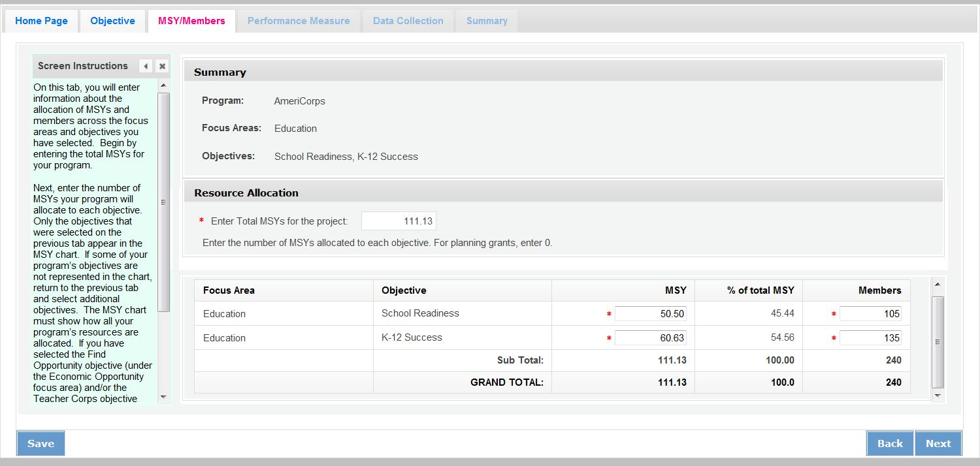

Note: Programs that select the Find Opportunity objective (Economic Opportunity Focus Area) or the Teacher Corps objective (Education Focus Area) must enter 0 MSYs and members for these objectives and allocate their MSYs to other objectives. This is because the MSY allocations are designed to show how programs’ resources are allocated to activities that benefit the community. The Find Opportunity and Teacher Corps objectives are focused on benefits to members.

How It Looks in the 424 PDF

Table 1 and its corresponding pie chart show the total number of MSYs by Focus Area. Since both the K-12 Success and School Readiness objectives are in the Education Focus Area, Table 1 shows 100% of MSYs in Education.
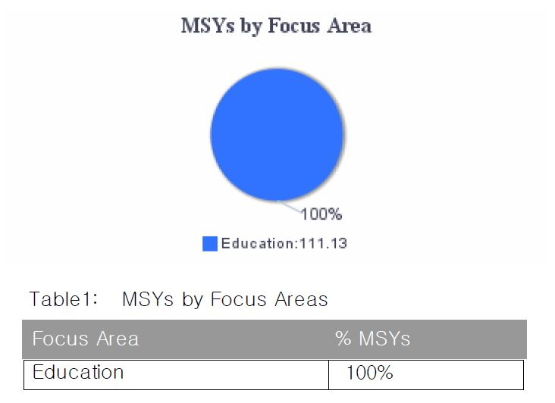
Table 4 in the PDF report shows the number of MSYs and members allocated to each objective, as seen on the MSY/Members tab:

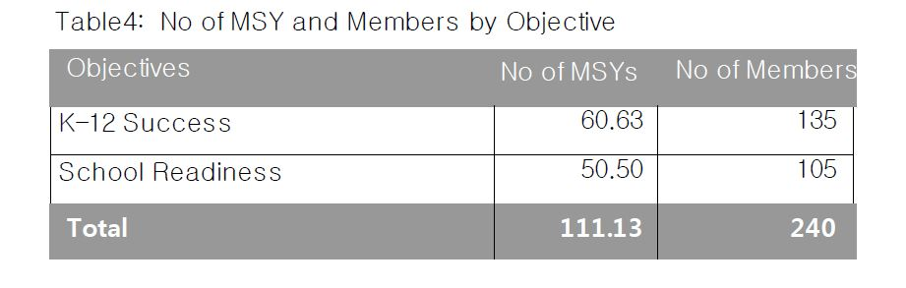
Because some members are performing service related to both K-12 Success and School Readiness, the total number of members listed in this table (240) is greater than the total number of slots the program is requesting (135). This is OK; individual members can be counted more than once if they contribute to more than one objective. In contrast, MSYs cannot be counted more than once, because they represent the amount of member time spent on a particular objective. As a result, the total number of MSYs listed in this table must be equal to the total MSYs the program is requesting (111.13).

Table 2 and its corresponding pie chart show the same MSY information expressed as percentages of the total MSYs:
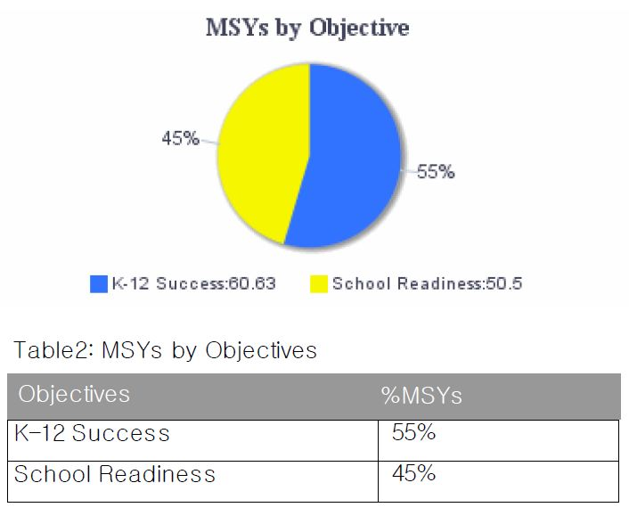
How to Assign MSYs to Performance Measures

When a program creates a performance measure, it must indicate how many MSYs and how many members will contribute to the measure. Based on the MSY allocations already entered for the sample program, the program may allocate up to 60.63 MSYs to K-12 Success performance measures and up to 50.5 MSYs to School Readiness performance measures. However, programs are not required to measure all of their activities, so it is possible that not all of these MSYs will be allocated to performance measures.

Our sample program has three performance measures, one (an aligned measure) under the K-12 Success objective and two (an output-only measure and an applicant determined measure) under the School Readiness objective.

Objective #1: K-12 Success
Intervention | Performance Measure | Percent of K-12 Success Time Spent on Activities that Contribute to this Measure | x | Total MSYs in Objective | = | MSYs Allocated to Performance Measure
Mentoring* | ED1A, ED27C | .75 | x | 60.63 | = | 45.47
Family Involvement | No Performance Measure | .25 | x | 60.63 |  | NA
*This is the primary intervention

Objective #2: School Readiness
Intervention | Performance Measure | Percent of School Readiness Time Spent on Activities that Contribute to this Measure | x | Total MSYs in Objective | = | MSYs Allocated to Performance Measure
Other Classroom Support | ED1A | .75 | x | 50.5 | = | 37.88
Parent Engagement | Applicant-Determined Measure | .25 | x | 50.5 | = | 12.62

How It Looks in the 424 PDF

Table 3 and its corresponding pie chart in the 424 PDF report shows the percentage of MSYs allocated to National Performance Measures, applicant-determined performance measures, or no performance measures. As seen in the table above, the program has two National Performance Measures (ED1A/27C and ED1A), accounting for 83.35 of the 111.13 total MSYs (75%). The program has one applicant-determined measure accounting for 12.62 MSYs (11%), and the remaining percentage (14%) of program activity is not being measured.
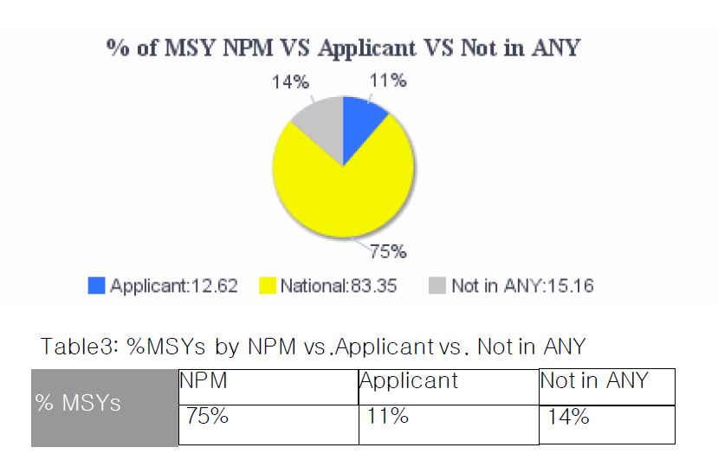
The configuration above meets the AmeriCorps requirement to have one aligned performance measure (output + outcome) corresponding to the primary intervention. Programs are not required to allocate 100% of their MSYs and members to National Performance Measures, or to any performance measures at all.

Appendix B: Performance Measures Checklist

This checklist is used to assess performance measures during the review process. Items on the checklist are common problems that require resolution but do not represent a comprehensive list. Refer to the Performance Measure Instructions for full requirements.

Checklist Item |  | Primary Aligned Measure (required) | Additional Measure  (optional) | Additional Measure  (optional)
Resource Allocation
1 | MSY and member allocations to focus areas and objectives are consistent with the application narrative/logic model.
2 | MSY and member allocations to performance measures are consistent with the application narrative/logic model.
Performance Measure Requirements
3 | The application includes least 1 aligned performance measure (output + outcome) corresponding to the primary intervention.
4 | All performance measures reflect significant program activities whose outputs and outcomes are consistent with the applicant’s core theory of change.
5 | Any output-only measures included in the application consist solely of National Performance Measure outputs.
6 | The application does not include applicant-determined measures that duplicate existing National Performance Measures. (Note: Applicant-determined measures are recognizable by the labels OUTPT or OUTCM, followed by numbers. Any applications containing these labels are NOT National Performance Measures, even if the applicant has labeled them like a national measure.)
Interventions
7 | Interventions are consistent with the program design and contribute directly to the outputs and outcomes.
8 | The application does not include user-defined intervention labels that duplicate existing system-defined intervention categories.
Output Quality
9 | Outputs clearly specify what is counted.
10 | Outputs count only program beneficiaries, not National Service Participants.
Outcome Quality and Alignment
11 | Outcomes are logically aligned with the outputs.
12 | Outcomes reflect a meaningful change in knowledge, attitude, behavior or condition for program beneficiaries. (Note: completion of a program would be considered an output, not an outcome.)
13 | Outcomes can be measured during a single grant year.
Targets
14 | Output and outcome targets are reasonable for the proposed program design.
15 | Targets are expressed as numbers, not percentages.
Performance Measure Instructions
16 | National Performance Measures conform to selection rules, definitions, and data collection requirements specified in the Performance Measure Instructions.
17 | The application does not include any retired National Performance Measures (e.g., measures that do not appear in the Performance Measure Instructions).
Data Collection/Instruments
18 | Data collection methods are appropriate for the output/outcome being measured.
Sampling (if applicable)
19 | If sampling is proposed, the sampling plan is forwarded to AmeriCorps for consideration. (Note: Formula grantees are not permitted to sample.)

Appendix C: Frequently Asked Questions

- What should a continuation applicant do if one or more of their National Performance Measures is no longer present in the Performance Measure Instructions?

All applicants, including continuation applicants, must follow the National Performance Measure selection rules specified in the current Performance Measure Instructions. Applicants must revise their performance measures as needed to conform to the updated instructions.

- What should a continuation grantee who is measuring a National Performance Measure output or outcome that has a changed definition do in the continuation application?

If the grantee is unable to measure the output or outcome as defined in the current Performance Measure Instructions, the grantee should choose a different performance measure.

- What are National Performance Measures?

AmeriCorps has established six Focus Areas: Disaster Services, Economic Opportunity, Education, Environmental Stewardship, Healthy Futures, and Veterans and Military Families based on the priorities included in the Serve America Act. Within these Focus Areas, as well as for Capacity Building, AmeriCorps has created National Performance Measures in order to aggregate the results of similar programs and demonstrate the impact across our agency programs and initiatives.

- What is an aligned performance measure?

An aligned performance measure is an output paired with an outcome. The paired output-outcome measures may be National Performance Measures, applicant-determined measures, or the combination of a National Performance Measure output and an applicant-determined outcome. Applicant-determined outputs cannot be paired with National Performance Measure outcomes in an aligned performance measure.

- What is an applicant-determined performance measure?

An applicant-determined performance measure is one in which the applicant creates the language for the outputs and/or outcomes that will be measured. This is different from the National Performance Measures, where AmeriCorps pre-determines common outputs and outcomes that are available for applicants to use.

- What is an output-only performance measure?

An output-only measure is a National Performance Measure output without associated outcome(s). Applicants may select output-only measures if the output measures a significant program activity. These do not fulfill the requirement for an aligned performance measure, but may be selected in addition to the aligned measure(s).

- What is the definition of "National Service Participant"?

For AmeriCorps State and National programs, National Service Participant refers to the AmeriCorps members themselves.

- Can I count AmeriCorps members as beneficiaries of service under my performance measures?

No. Effective starting in 2019 for all applicants (new, recompete, and continuation), AmeriCorps members and other National Service Participants may not be counted as beneficiaries under either National Performance Measures or applicant-determined measures. Some member-focused outputs and outcomes may be reported as Performance Data Elements on annual Progress Reports.

- Do the AmeriCorps members in my program have to be directly providing the service counted in the performance measures?

The activities associated your performance measures must be carried out either by National Service Participants or by volunteers directly recruited and/or supported by National Service Participants.

- How many performance measures should I propose?

Each program must have at least one aligned measure (composed of an output and an outcome) reflecting its primary intervention. It is appropriate to have additional performance measures for other significant components of your program, but AmeriCorps values the quality of performance measures more than the quantity. Performance measures reflecting activities that are not central to your program model should not be included in your application and do not need to be reported to AmeriCorps, although you might still collect the data for your own purposes.

- Can I count the same beneficiaries in more than one performance measure output?

Unless otherwise specified, the same beneficiaries may be counted more than once across different measures for different interventions (services) they may be receiving. For example, if your AmeriCorps members helped one specific individual to both prepare for a disaster and obtain employment, you may count that same individual in both D1A and O1A. However, programs cannot count the same individual more than once within any one specific performance measure. So, for example, an individual who attended two disaster preparation training workshops during a single program year cannot be counted twice under D1A.

- Do all beneficiaries counted under a particular performance measure have to receive the same interventions?

Yes, the interventions associated with the measure need to be applicable to all of the beneficiaries counted under the measure, even if the details of the intervention (e.g., the exact dosage provided) may vary. If one set of beneficiaries is receiving one type of intervention (e.g., mentoring) and a different set of beneficiaries is receiving a different type of intervention (e.g., tutoring), the two sets of beneficiaries should be counted in separate performance measures even if the expected outcome is the same. In contrast, if all beneficiaries are receiving multiple interventions with the same expected outcome (e.g. all beneficiaries are being both mentored and tutored to improve their academic performance), they can be counted in a single performance measure.

- Can one performance measure output have more than one outcome?

Yes, there may be more than one outcome measure associated with a single output. Aligned measures should only be configured this way if it is expected that all of the individuals counted in the output will potentially achieve the outcomes indicated. If the outcomes are resulting from different populations being served, they should be counted in distinct performance measures.

- Can I count the same people more than once under one performance measure output or outcome if they receive service in more than one grant year?

If the individual receives services in more than one grant year, they may be counted as having received services in the output measure for each of the grant years in which they receive services. They may only be counted in the outcome measure for each grant year if they meet the specified level of improvement for the outcome in each year. For example, a student receives tutoring in second and third grade. The program expects that students will improve their reading score by one grade level each year. If the student is served in both second and third grade and improves by one grade level in each year, the student may be counted in output ED1A and outcome ED5A for both years. If the student improves by ½ grade level in second grade and one grade level in third grade, the student may be counted in ED1A for both years but only in ED5A for the third-grade year.

- Am I allowed to allocate funds for collecting and analyzing data? If so, how much?

Costs related to measuring the performance of a program are allowable grant expenses. There is no standard recommended amount. As with all grant expenditures, these costs must be reasonable, allowable for the proposed program, and properly allocated across grant activities.

- Is my program expected to monitor member time to ensure that it corresponds to what is entered into the Performance Measures Module for the focus areas and strategic plan objectives?

Applicants should enter MSYs and members according to the distribution of time that members are expected to engage in each focus area and strategic plan objective. Programs will not be required to report on how the members actually spent their time. MSY allocations in the application should present the program’s best estimate.

- On the logic model chart there are three outcome levels (short, medium and long). Should all of these outcomes be entered as performance measures?

A program may have a theory of change that is based on accomplishing a long-term change in condition that is not measurable in a single program year. However, there may be shorter-term changes that can be linked to this ultimate goal that are strong indicators that the long-term change is likely to happen. While all of these outcomes may be included in the logic model, grantees are not required to measure or report on all of the outcomes. For performance measurement purposes, outcomes must measure changes that can be observed within a single program year.

- The National Performance Measure I want to select doesn’t appear in the drop-down menu. What should I do?

Only performance measures corresponding to objectives selected on the Objectives tab will appear in the drop-down menu. Refer to the Performance Measure selection rules to determine which objective to select for each performance measure. Do NOT create an applicant-determined measure that duplicates a National Performance Measure.

- I want to create an applicant-determined measure, but the Performance Measures Module isn’t allowing me to do that. What should I do?

There are some objectives for which the creation of applicant-determined outputs is not allowed. These include the Capacity Building and Leverage objective (Capacity Building focus area), the Find Opportunity objective (Economic Opportunity focus area), the Teacher Corps objective (Education focus area), the Green Jobs objective (Environmental Stewardship focus area), and the Access & Attract objective (Veterans and Military Families focus area). For the Capacity Building and Leverage objective, only National Performance Measure outputs are allowed to be used. For the Find Opportunity, Teacher Corps, Green Jobs, and Access & Attract objectives, programs are not allowed to create performance measures.

- I am required to have a performance measure associated with my primary intervention, but I am not able to create a performance measure for the primary intervention I have selected. What should I do?

Since the Find Opportunity, Teacher Corps, Green Jobs, and Access & Attract objectives are member-focused rather than beneficiary-focused, programs are not allowed to create performance measures under these objectives (see FAQ 9). If your primary intervention is connected to one of those objectives, you will need to go back and select a different primary intervention under a different objective. You can retain the member-focused objective as secondary.

- Under what circumstances is it ok for grantees to use sampling to measure outputs and outcomes?

Methodologically speaking, sampling is appropriate for competitive grantees as long as the grantee has a solid plan for ensuring that its sample will be representative. Practically speaking, we would want grantees to use sampling only when they are able to make the case that it is unrealistic to collect data from the whole population. Formula grantees, with rare exceptions granted by AmeriCorps, are not permitted to sample.

- When would AmeriCorps not allow sampling?

AmeriCorps will not allow sampling when it is reasonable to expect a grantee to collect data from the whole population. AmeriCorps will also not allow sampling if the grantee’s sampling frame is not sufficient or if the grantee’s methodology will not result in a representative sample.

- How does a grantee set targets when it is planning to sample?

In most cases the grantee should be able to set targets based on the population as a whole. If a grantee‘s sampling methodology is sound and results in a representative sample, then the program can extrapolate their results to report on an outcome for the population as a whole. For example, a program reports an output of 1000 children served. The program selects a representative sample of 200 children. Of these, 180 students (90%) demonstrate the desired change. In this case, the program could report an extrapolated outcome of 900 students.

- How do I request permission to sample?

A detailed sampling plan must be forwarded to AmeriCorps for consideration. Please consult the Notice of Funding Opportunity or your Portfolio Manager for instructions on how to submit additional documents.

